Program priority: Supporting a smarter Adriatic - Ionian region
Specific objective: SO. 1.1: Strengthening innovation capacities in the Adriatic - Ionian region
Project acronym and title: ABBA - Adriatic-Ionian SustainaBle Blue Economy Alliance for upscaling SMEs
Project ID: IPA-ADRION00284

Open call for Applications template

Open Call Application Template for the ABBA open call to early-stage deep tech innovators. The ABBA consortium will evaluate the received applications using fair and predefined selection criteria, ultimately selecting 30 blue deeptech innovators for service provision.

Contents
1. Introduction 3
2. Guidelines for filling the Application Form 4
3. Application Template 5
4. Declaration of Honour 11

- Introduction
This document has been developed under Deliverable D.1.3.1 – Open Call & Evaluation Methodology for Applications, within the framework of the ABBA project (Adriatic-Ionian SustainaBle Blue Economy Alliance for upscaling SMEs), co-funded by the Interreg IPA ADRION Programme.
The purpose of this document is to provide the official application template for the ABBA Open Call. This template is designed to guide applicants—such as SMEs, startups, spin-offs, research teams, student groups, and individuals—through the submission process, ensuring that all relevant information is collected in a clear and structured manner.
The application form is composed of the following sections:
- Applicant Details: Basic information about the applicant, including organization type, contact details, and background.
- Solution Description: A concise overview of the proposed solution, including its relevance to ABBA’s thematic sectors and challenges.
- Business & Innovation Overview: A simplified business model section covering the value proposition, customer needs, resources, team, and development stage.
- Open Innovation & Collaboration: Information about the applicant’s current stage in the innovation cycle and their needs for partnerships or support within the ABBA ecosystem.
- Optional Attachments: Applicants may include a pitch deck or other supporting materials to strengthen their submission.
In addition, the application includes a Declaration of Honour, confirming the applicant’s eligibility and agreement with the terms of the ABBA Open Call, including data protection provisions.
Guidelines for completing and submitting the application form are provided in the Call Document, and in this Application document. Applicants are encouraged to read all sections carefully and provide clear, concise, and honest responses.

- Guidelines for filling the Application Form
To ensure a smooth and successful submission to the ABBA Open Call, all applicants are kindly requested to follow the guidelines below:
- Complete all sections of the application form. Each section is designed to help the evaluation team understand your solution, its potential, and your support needs.
- Respect the character limits indicated in each section. Unless otherwise stated, responses should not exceed 1000 characters per question.
- Be clear and concise. Use plain language to describe your solution, its impact, and your team. Avoid jargon where possible.
- Provide relevant and specific information under each heading. Use the guiding questions in each section to help structure your answers and highlight the strengths of your proposal.
- Submit the required declarations along with your application: The Declaration of Honour, confirming your eligibility and agreement with the ABBA Open Call terms.
- Optional but encouraged: You may include a pitch deck, diagrams, visuals, or other supporting materials in the attachments section to help illustrate your solution.
These guidelines aim to ensure fairness, clarity, and consistency across all applications. If you have any questions during the process, please refer to the official ABBA Open Call documentation or contact the support team.

- Application Template
Applicant Details
Name of the Applicant (Organization / Team / Individual)
Type of Applicant | ☐ SME ☐ Startup ☐ Spin-off ☐ Research Team ☐ Entrepreneurship Team ☐ Individual Researcher ☐ Individual Entrepreneur
Legal Status (if applicable)
VAT Number (for companies)/ ID (for team representative / individual applicant)
Country | ☐ Greece ☐ Italy ☐ Croatia ☐ Montenegro ☐ Albania ☐ Bosnia & Herzegovina
Region
City
Phone number (Include country code)
Website / social media (if any)
Short Profile / Background
(Brief description of the applicant’s background, expertise, or mission – max 1000 characters)

Contact Person Details
First name
Surname
Position (if applicable)
Phone number
E-mail
Solution Description
Title of the Solution/Service/Product | (Give your innovation a clear and concise name)
Which blue economy sector(s) does your solution primarily address?  (Select one or more that apply) | ☐ Port activities  ☐ Maritime transport  ☐ Marine renewable energy  ☐ Sustainable aquaculture & fisheries  ☐ Shipping  ☐ Shipbuilding & repair  ☐ Blue bioeconomy and biotechnology
Which of the following key challenges does your solution aim to tackle?  (Select one or max two that apply) | ☐ Addressing rising sea levels, extreme weather events, and coastal erosion, occurring from climate change  ☐ Promoting marine energy efficiency solutions through renewable energy or alternative fuels (biogas, wave, and tidal energy, offshore wind, etc.)  ☐ Promoting circular economy practices such as waste management, treatment & valorization, eco-design, recycling materials, etc.  ☐ Combatting overfishing, protecting ecosystems, and ensuring sustainable management of biodiversity  ☐ Supporting Sustainable Maritime Spatial Planning and environmental conservation  ☐ Promoting port & vessels digitalization and automation solutions for emissions reduction  ☐ Promoting grid integration to overcome infrastructure gaps  ☐ Promoting green shipbuilding & repair process
Briefly describe your solution
(What is it? What problem does it solve? How does it work? - max 1000 characters)

Technology readiness level (TRL) of the solution | ☐TRL 1 – basic principles observed  ☐TRL 2 – technology concept formulated  ☐TRL 3 – experimental proof of concept  ☐TRL 4 – technology validated in lab  ☐TRL 5 – technology validated in relevant environment (industrially relevant environment in the case of key enabling technologies)  ☐TRL 6 – technology demonstrated in relevant environment (industrially relevant environment in the case of key enabling technologies)  ☐TRL 7 – system prototype demonstration in operational environment  ☐TRL 8 – system complete and qualified  ☐TRL 9 – actual system proven in operational environment (competitive manufacturing in the case of key enabling technologies; or in space)
Business & Innovation Overview
Customer Pain & Target Market: What problem or need are you addressing? Who experiences this problem and why is it important to address it? Which is your target market? Include info on the competition if relevant
(max 1000 characters)

Technology & Value Proposition: What is your solution and what value does it offer?
Describe the core advanced technology or concept behind your solution. What makes it innovative? What value does it bring to users or the blue economy sector?
(max 1000 characters)

Resources & Revenue: What resources do you need to develop or scale your solution? If applicable, mention your cost structure and how you plan to generate revenue or sustain your solution: What are the most important costs inherent in your business model?
(Examples of Resources: Physical - Intellectual (brand patents, copyrights, data) – Human – Financial resources)
(max 1000 characters)

Team: Introduce your team or yourself. Highlight relevant skills, experience, or motivation. If you’re applying as an individual, you may include a short cover letter-style statement.
(max 1000 characters)

Impact: What positive environmental, economic, or social impact do you expect your solution to have on the local/ national/ Adriatic-Ionian Region level?
(max 1000 characters)

Pitch Deck or Supporting Materials (Optional): You may upload a pitch deck, presentation, or any other supporting material that helps explain your solution. This is optional but recommended if you have visuals, diagrams, or additional context that can strengthen your application.
- Accepted formats: PDF, PPT, or link to an online presentation (e.g., Google Slides, Notion, etc.)
- Maximum file size: 10 MB
- If submitting a link, please ensure it is publicly accessible.

Upload or paste link here:
Open Innovation (OI) Stages and Collaboration Needs
Are you looking for partners to help you develop or scale your solution?
Please describe what kind of collaboration you are seeking. What type of partners would be most helpful (e.g., research institutions, companies, public authorities, ports, etc.)? Have you already identified or started working with any partners?
(max 1000 characters)

Which stage best describes where you are in your innovation process? | ☐Trigger Point – You have identified a challenge or opportunity and are exploring ideas  ☐Consent Development – You are developing or testing a prototype or early-stage solution  ☐Commercialization & Follow-up – You are preparing to scale, pilot, or bring your solution to market
Select the areas where you would benefit from Open Innovation partnerships: | ☐Scientific or technical expertise  ☐Understanding customer needs or user feedback  ☐Access to enabling technologies, IPR, or licensing  ☐Navigating regulations and standards  ☐Co-developing business models  ☐Access to production or testing facilities  ☐Supply chain or logistics support  ☐Distribution or market access
Choose all the types of OI partners you are seeking for | ☐Research institutions or universities  ☐Complementary technology providers  ☐Customers or end users  ☐Suppliers or manufacturers  ☐Ports, shipping companies, or shipyards  ☐Public authorities or regulators  ☐Innovation hubs, accelerators, or clusters  ☐Other: ___________
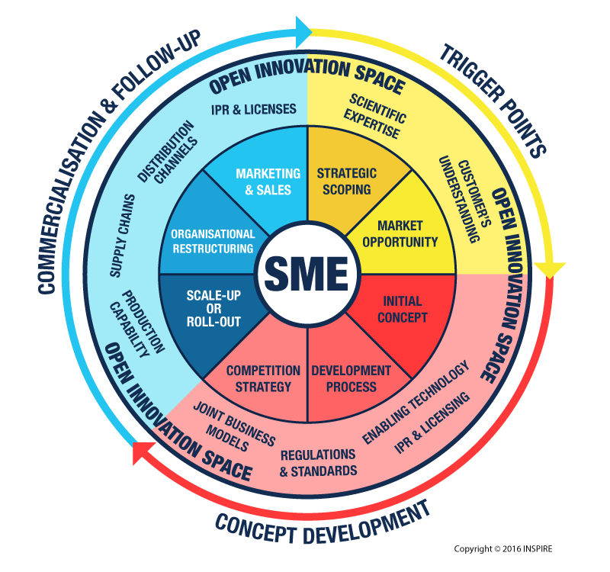

Declaration of Honour
This form is included in the online application form
Declaration of Honour
Each applicant understands and agrees the following conditions (please select all boxes)
ABBA Call Terms and Conditions
☐I agree with the ABBA terms and conditions specified in the guide for applicants
☐I confirm that the applicant is based in Greece, Italy, Croatia, Montenegro, Albania or Bosnia & Herzegovina
☐I confirm that at least one member of the applicant entity, who is strongly related to the proposed solution, is English Fluent
☐I confirm that the data and documents submitted, and all conditions and obligations stated in the Call are accurate and truthful
☐I declare that there is not in a situation of conflict of interest with the ABBA Partners.
☐I give the permission to the ABBA Project Partners to process the data given only for management and statistic purposes (including publishing of general information) even through digital devices with respect of the security and privacy within the law Data processing by ABBA Project Partners will be made in accordance with the provisions of Regulation (EU) 2016/679 and the subsequent transposing laws (jointly, the ‘’GDPR’’).

The project is co-funded by the European Union through the Interreg IPA ADRION programme.

https://ec.europa.eu/research/participants/data/ref/h2020/wp/2014_2015/annexes/h2020-wp1415-annex-g-trl_en.pdf
https://www.inspire-smes.info/

